राष्ट्रीय प्रौद्योगिकी संस्थान, रायपर
National Institute of Technology Raipur (C.G.)

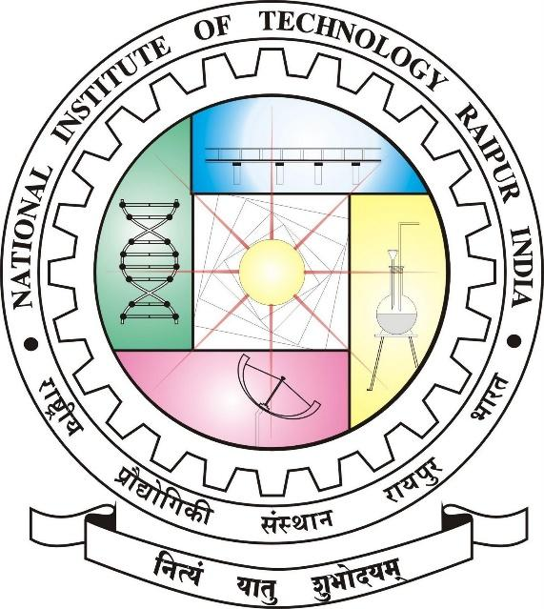

Department of Information Technology

Project Report on
HAND GESTURE BASED DIGITAL INTERACTIONS

Submitted to:  Dr. Gyanendra Kumar Verma  Assistant Professor Dept. of IT |  | Submitted by:  Nandigama Charanjit  Roll.no : 24265012  Nisar Ahmad  Roll.no :

